**CMSC 203 Assignment 5**

**Screenshots and Test Table**

Screenshot InputFile1:

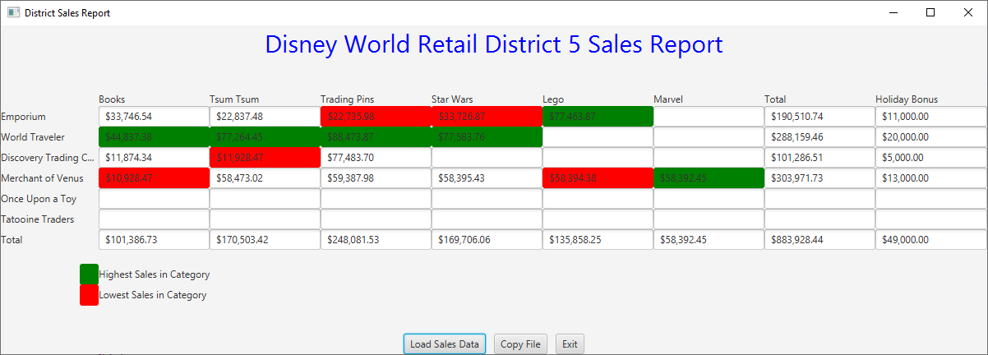

Screenshot InputFile2:

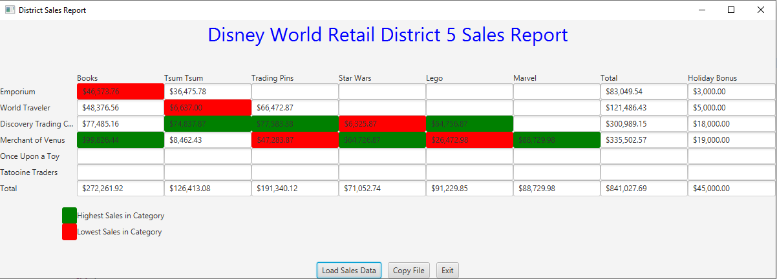

Test Table for InputFile2

|  |  |  |  |  |
| --- | --- | --- | --- | --- |
| **Test Case #** | **Input** | **Expected Output** | **Actual Output** | **Did the test pass?** |
| Column 1 | 46573.76­­­, 48376.56, 77485.16, 99826.44 | Highest: 99826.44  Lowest: 46573.76­­­ | Highest: 99826.44  Lowest: 46573.76­­­ | yes |
| Column2 | 36475.78, 6637.00, 74837.87, 8462.43 | Highest: 74837.87  Lowest: 6637.00 | Highest: 74837.87  Lowest: 6637.00­­­ | yes |